ECE 322L - Lab 3

February 12, 2013

Greg Iven

Mario Chaves

Table of Contents

Abstract 3

Procedure 3

Hand Calculations 4

PSPICE 6

PSPICE Code 6

PSPICE Simulation Output 6

Captured Results 8

Conclusion 9

List of Figures

Figure 1 - MOSFET Cascade Amplifier 3

Figure 2 – Output form built circuit 8

Figure 3 – input frequency 8

Figure 4 – Source voltages 9

Abstract

In this lab we constructed an MOSFET cascade amplifier which consists of a common-source amplifier that is followed by a source follower amplifier.

Procedure

From the given circuit we were to perform hand calculations and verify them using PSPICE. Once the circuit was simulated we were to then build the circuit and verify Vds, Vgs, and Ids and compare the results to the to the PSPICE simulation.



Figure - MOSFET Cascade Amplifier

## Hand Calculations





 🡪  🡪 

 🡪 



 🡪 



 🡪 

 🡪 

 🡪 

 🡪 





 🡪 

 🡪 

 🡪 



 🡪 

# PSPICE

## PSPICE Code

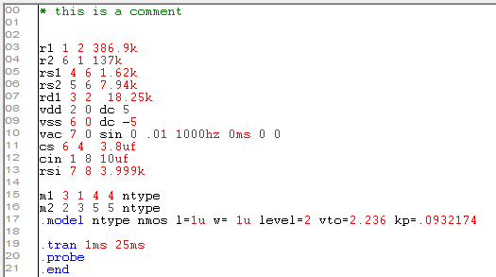

## PSPICE Simulation Output

**** 02/12/13 16:48:00 ****** PSpice 16.5.0 (April 2011) ****** ID# 0 ********

* this is a comment

**** CIRCUIT DESCRIPTION

******************************************************************************

r1 1 2 386.9k

r2 6 1 137k

rs1 4 6 1.62k

rs2 5 6 7.94k

rd1 3 2 18.25k

vdd 2 0 dc 5

vss 6 0 dc -5

vac 7 0 sin 0 .01 1000hz 0ms 0 0

cs 6 4 3.8uf

cin 1 8 10uf

rsi 7 8 3.999k

m1 3 1 4 4 ntype

m2 2 3 5 5 ntype

.model ntype nmos l=1u w= 1u level=2 vto=2.236 kp=.0932174

.tran 1ms 25ms

.probe

.end

**** 02/12/13 16:48:00 ****** PSpice 16.5.0 (April 2011) ****** ID# 0 ********

* this is a comment

**** MOSFET MODEL PARAMETERS

******************************************************************************

ntype

NMOS

LEVEL 2

L 1.000000E-06

W 1.000000E-06

VTO 2.236

KP .093217

GAMMA 0

PHI .6

LAMBDA 0

IS 10.000000E-15

JS 0

PB .8

PBSW .8

CJ 0

CJSW 0

CGSO 0

CGDO 0

CGBO 0

TOX 100.000000E-09

XJ 0

UCRIT 10.000000E+03

DIOMOD 1

VFB 0

LETA 0

WETA 0

U0 0

TEMP 0

VDD 5

XPART 0

**** 02/12/13 16:48:00 ****** PSpice 16.5.0 (April 2011) ****** ID# 0 ********

* this is a comment

**** INITIAL TRANSIENT SOLUTION TEMPERATURE = 27.000 DEG C

******************************************************************************

NODE VOLTAGE NODE VOLTAGE NODE VOLTAGE NODE VOLTAGE

( 1) -2.3850 ( 2) 5.0000 ( 3) 1.4574 ( 4) -4.6855

( 5) -.8841 ( 6) -5.0000 ( 7) 0.0000 ( 8) 0.0000

VOLTAGE SOURCE CURRENTS

NAME CURRENT

vdd -7.316E-04

vss 7.316E-04

vac 0.000E+00

TOTAL POWER DISSIPATION 7.32E-03 WATTS

JOB CONCLUDED

**** 02/12/13 16:48:00 ****** PSpice 16.5.0 (April 2011) ****** ID# 0 ********

* this is a comment

**** JOB STATISTICS SUMMARY

******************************************************************************

Total job time (using Solver 1) = .02

**** 02/12/13 16:48:00 ****** PSpice 16.5.0 (April 2011) ****** ID# 0 ********

**** CIRCUIT DESCRIPTION

# Captured Results

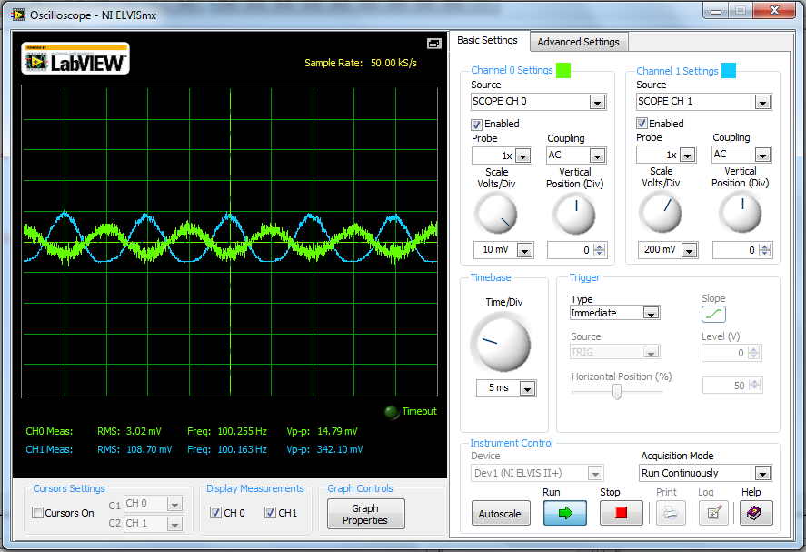

Figure 2 – Output form built circuit

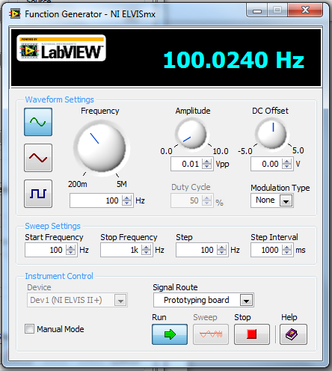

Figure 3 – input frequency

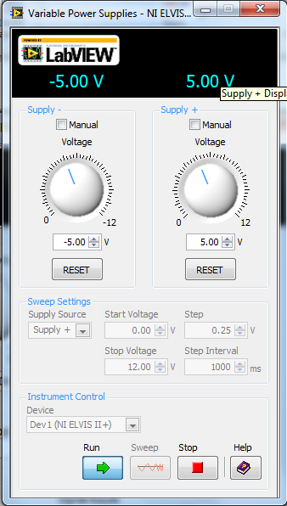

Figure 4 – Source voltages

Conclusion  
In performing this experiment we gained more experience with PSPICE by implementing a more involved circuit which will prove to be very helpful in the future. Through our hand calculations we were able to learn more about the electrical characteristics of transistors and calculate a more complex circuit including its gain. This amplifier circuit can be applied almost everywhere from audio amplifiers to sensor detection circuits. This lab gave us some grief using the ELVIS because of the intermittent connections and the extra internal impedances/capacitances within but, other that that this lab was a good lesson learned.